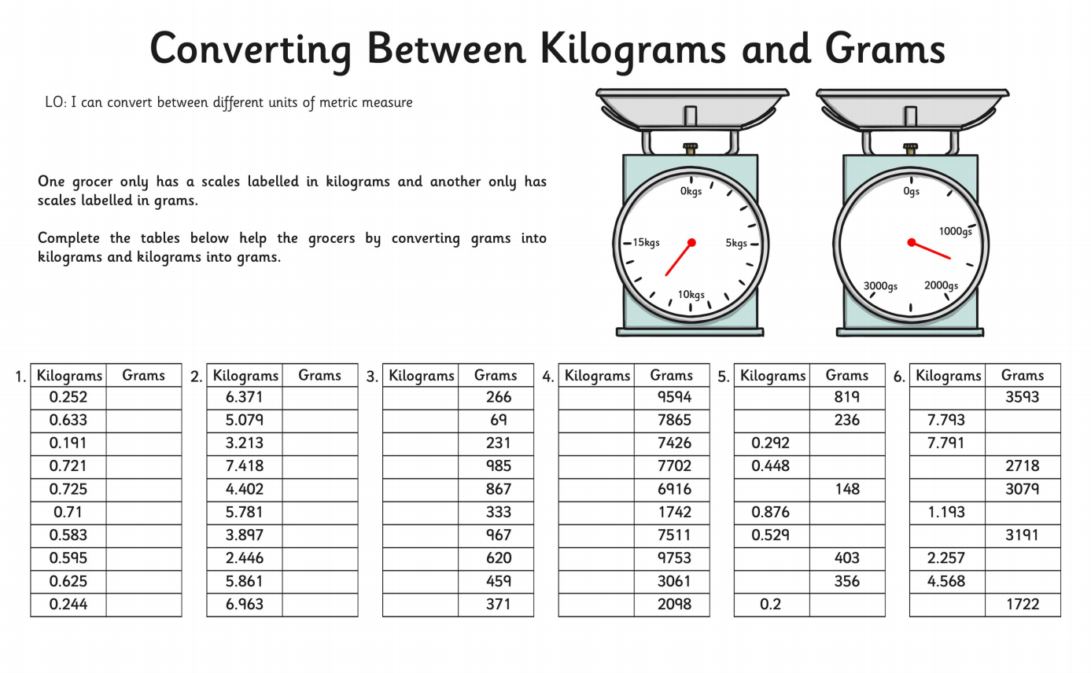
Name:……………………………………………………………………………………. 3.1 Read and compare units used to measure weight

